Milestone -4

Requirements:

1. Pip install flask
2. Pip install joblib
3. Pip install requests
4. Pip install scikit-learn
5. Expose model via model-prediction-service in the form of flask API.

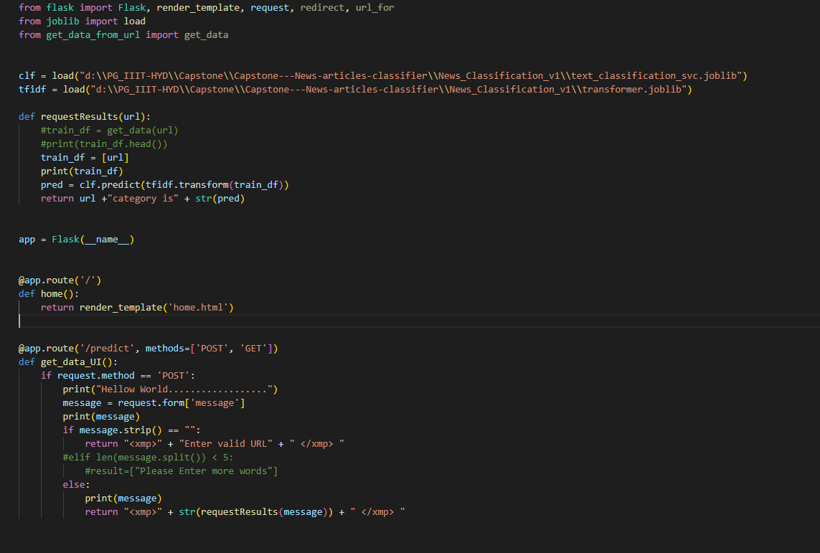

1. Dockerize all the projects by adding appropriate Dockerfile

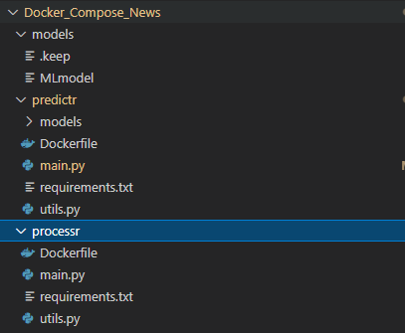

1. Prepare a simple HTML page containing a form to take an article as input and print the predicted category

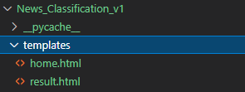

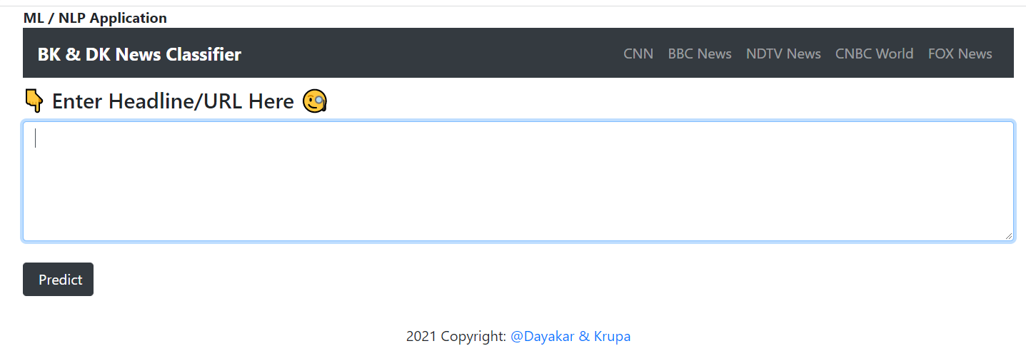

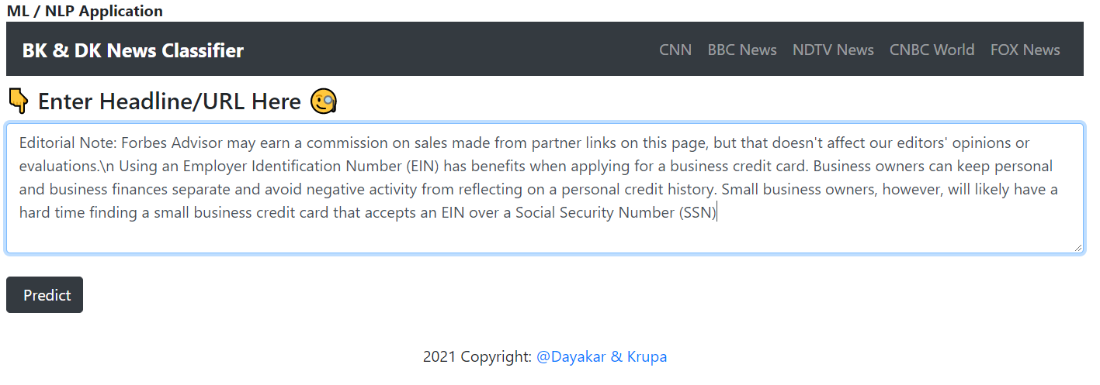

Predicted Category:



Additional Points:

ML results are difficult to reproduce

Wordcloud

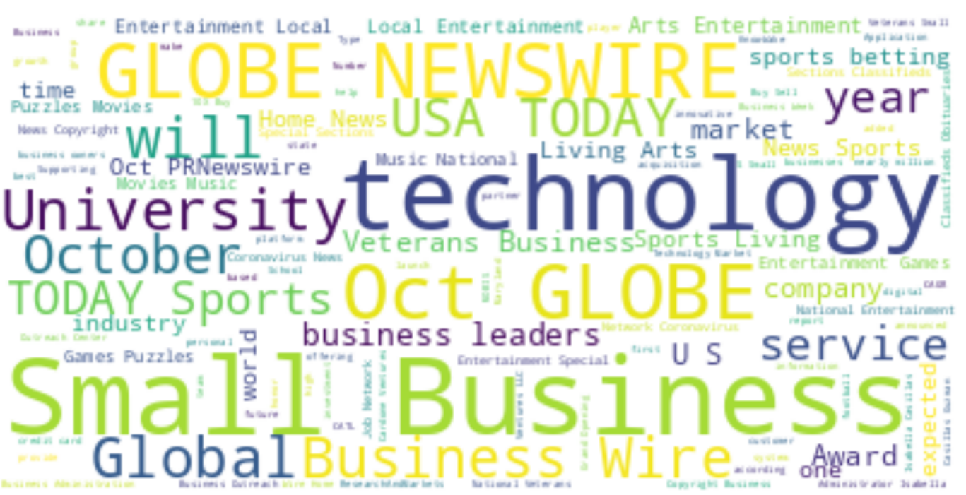

After generating model for different models, select the best model and use that in the web application development

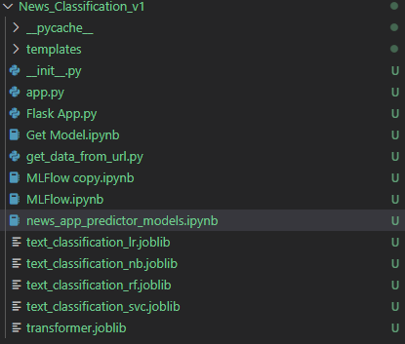

Model accuracies for the models are as below

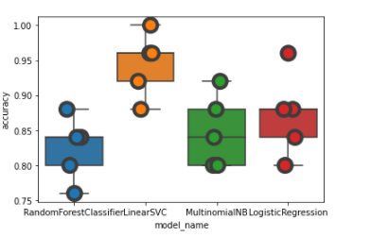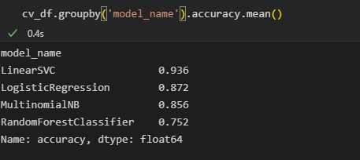

Once we get the model files saved

Run the flask api

Notes:

As the data we are getting from fastapi the classification of the topic is not good or accurate . in most of the cases the data is miss classified.

As this capstone project is not focused on accuracy of the model we are diving deep into the problem to improve the accuracy of the model.

Rather we are building an whole architecture to develop an user interface with flask api where user can enter the text and model will predict the type of news,

The type of news is from the trained data only, if we need the prediction accuracy exactly match, we need to refine the model.